**Phase 1 -Lockme.com Screenshots**

Fig 1. Printing list of files in the system

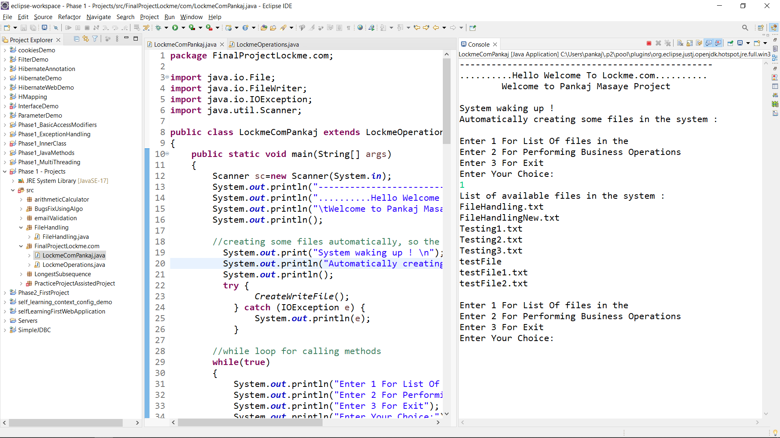

Fig 2. Creating new file named PankajFileTesting

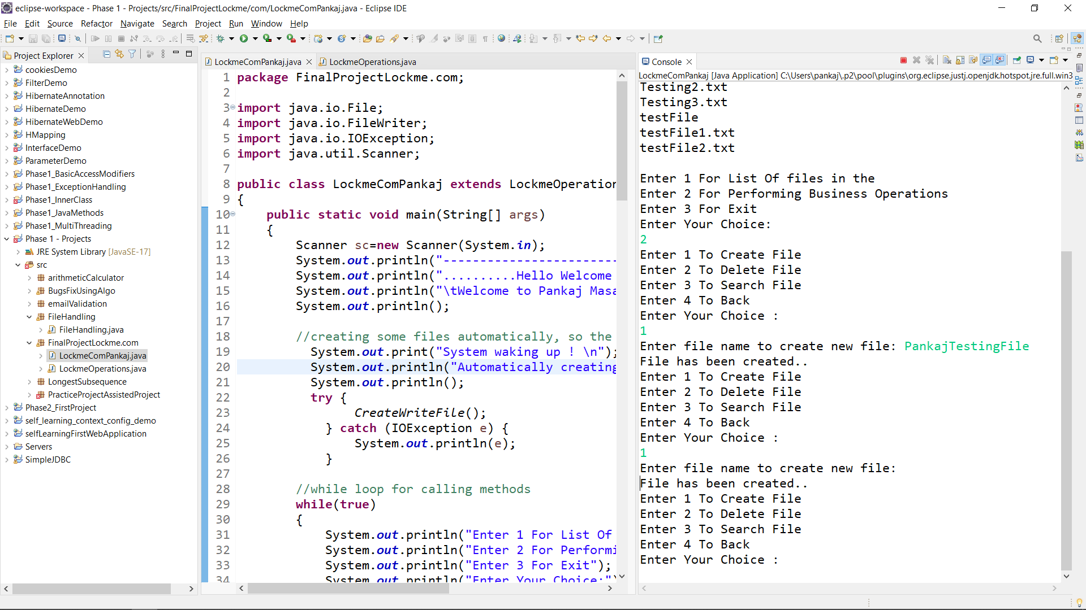

Fig 3. Printing list of files, after creating a new file named PankajTestingFile

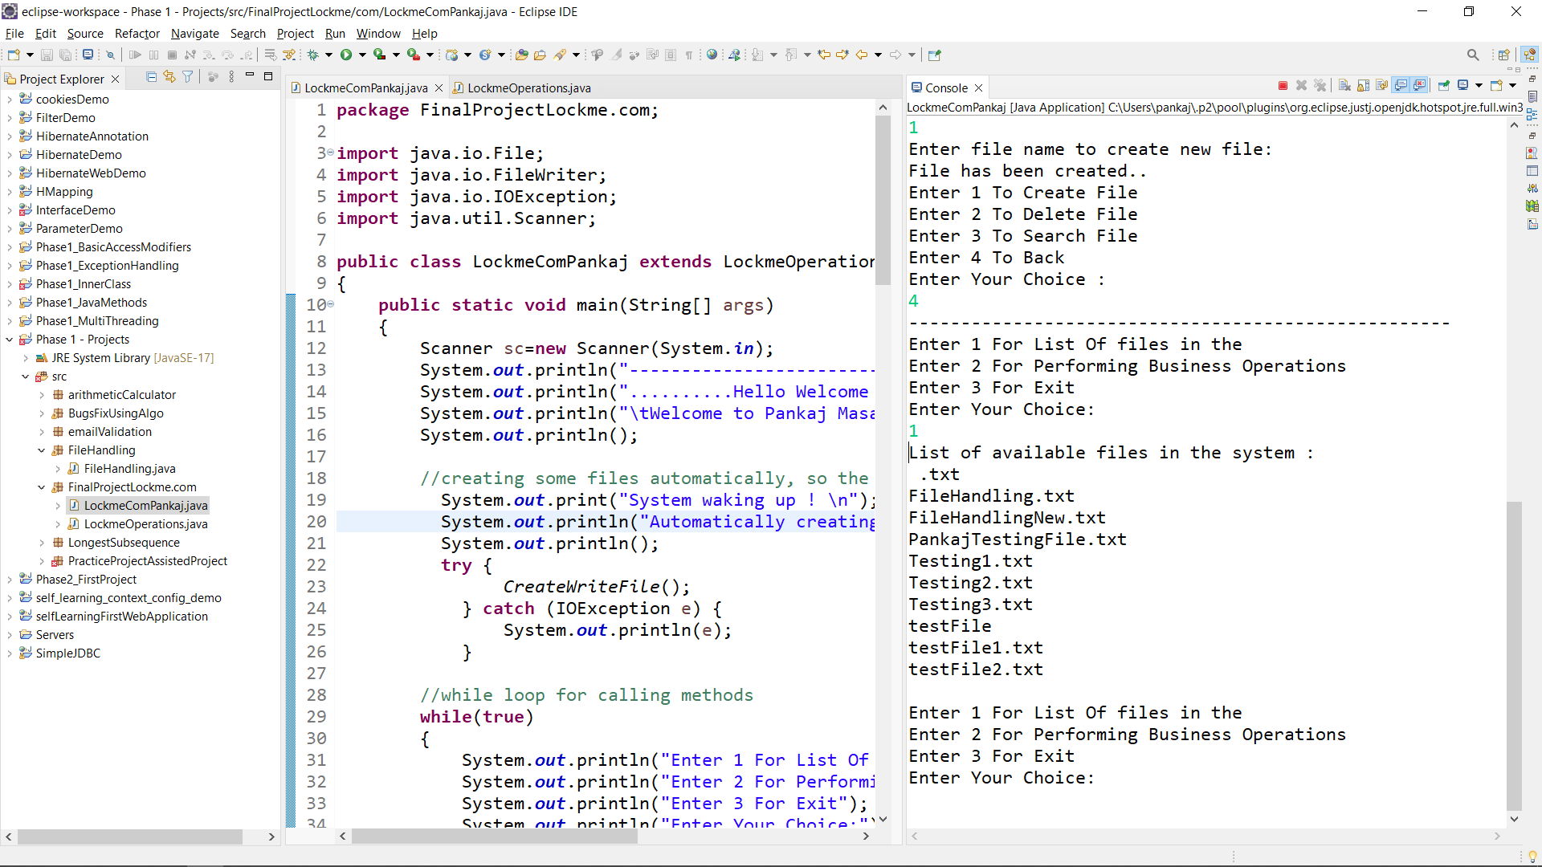

Fig 4. Removing a file from the system.

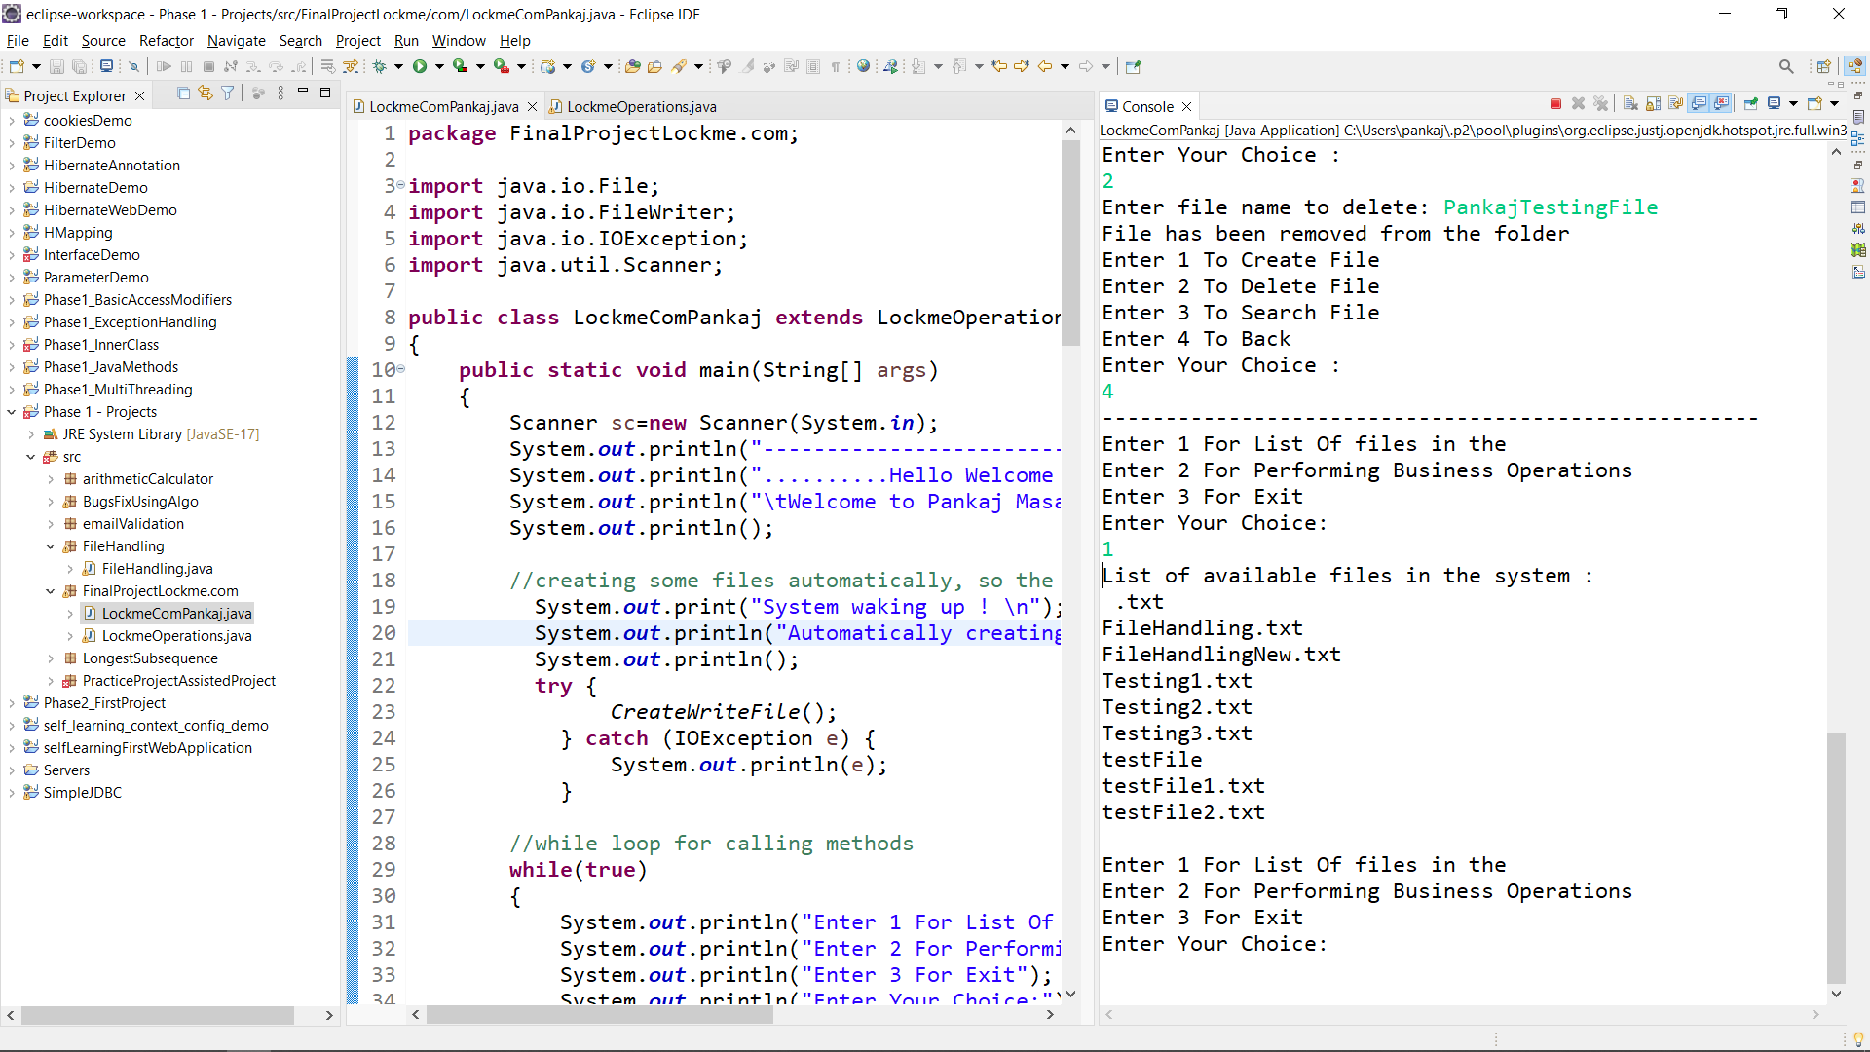

Fig 5. Searching file name. One is present, second file is already deleted so could not find

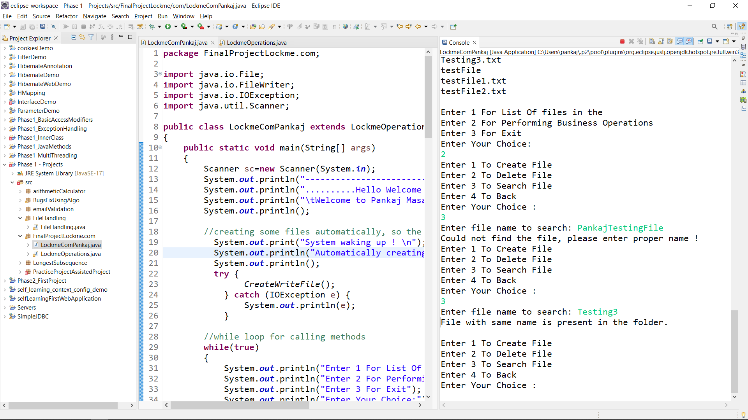

Fig 6. Existing the system with a message.

